**PRACTICAL 1**

**Aim: Create new ASP.NET Core MVC project using each of the following**

**1. Terminal**

**2. VS Code**

**• Set the HTTP port 5000 and HTTPS port 5001**

**• Run the above created project using:**

**1. Terminal**

**2. VS Code**

**Steps:**

**Creating a New ASP.NET Core MVC Project**

#### Using Terminal

1. Open the terminal.
2. Navigate to the directory where you want to create your project.
3. Run the following command to create a new ASP.NET Core MVC project:

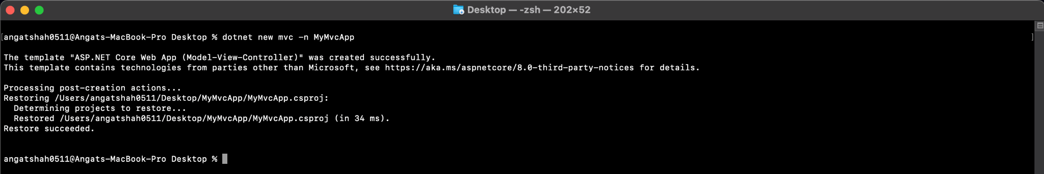

Using VS Code

1. Open Visual Studio Code.
2. Open the terminal in Visual Studio Code.
3. Navigate to the directory where you want to create your project.
4. Run the following command to create a new ASP.NET Core MVC project:

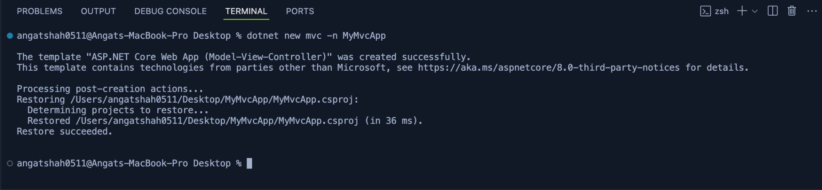

**Setting the HTTP and HTTPS Ports**

1. Open the ‘launchSetting.json’ file located in the ‘Properties’ folder of the project.
2. Update the ‘launchSettings.json’ file to set the HTTP port to 5000 and the HTTPS port to 5001:

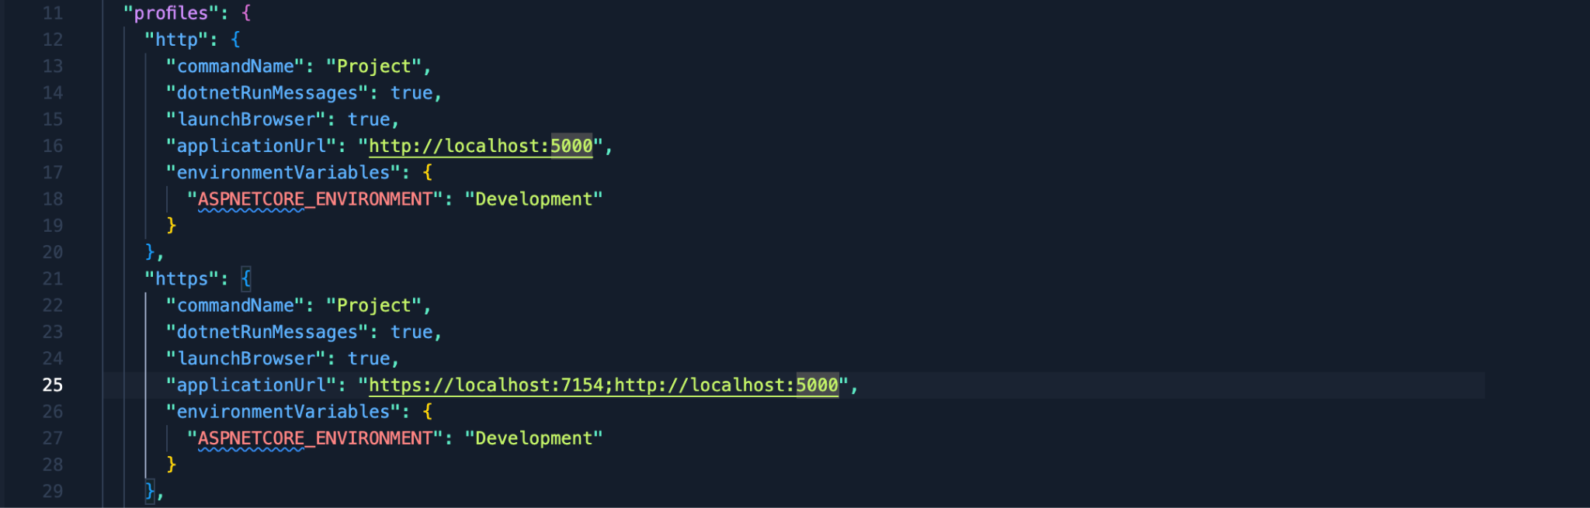

**Running The Project**

#### Using Terminal

1. Open the terminal.
2. Navigate to the project directory (‘MyMvcApp’).
3. Run the project using the following command: dotnet run
4. Open your web browser and navigate to ‘<http://localhost:5000>’ or ‘<https://localhost:5001>’

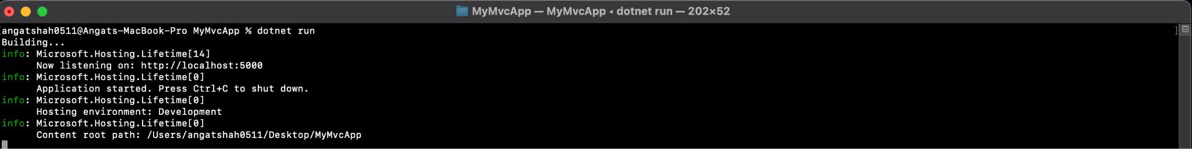

Using VS Code

1. Open the project directory (‘MyMvcApp’) in Visual Studio Code.
2. Open the terminal in Visual Studio Code.
3. Run the project using the following command: dotnet run
4. Open your web browser and navigate to ‘<http://localhost:5000>’

